1 st Week project

Lets get started with Power BI.

In Power BI ,BI stands for Business Intelligence.

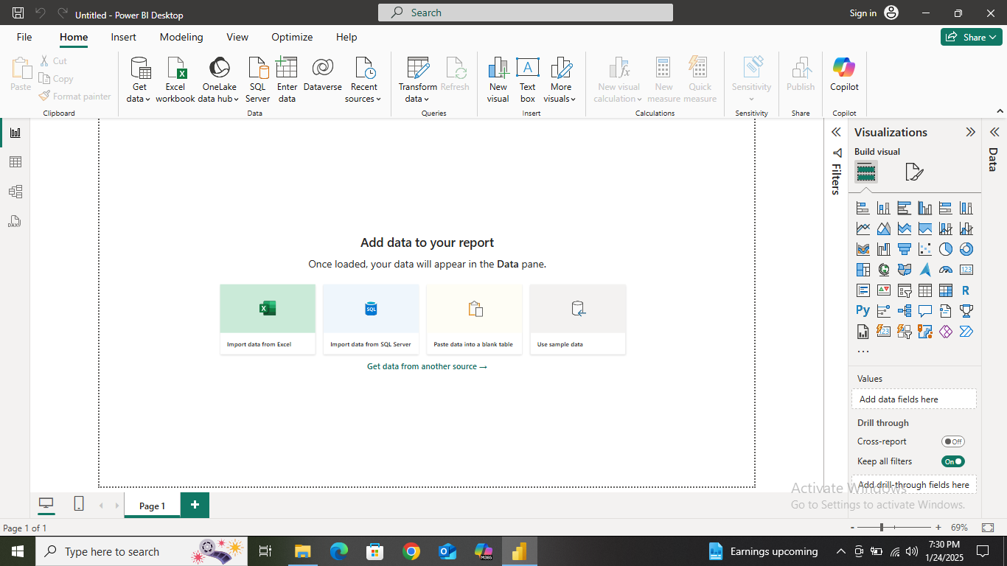

Step 1: Open Power BI Desktop ,click on blank report.

Step 2:Click on icon of import data from excel.

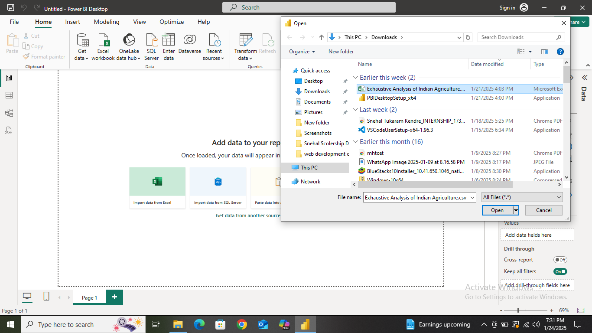

This window will appear.

Step 3: To import data in comma separated value (csv) from clicking on data set and open .

Step 4: this window will appear , click Transform Data.

We should not click load data because data is loaded when it is clean data .

Our data is not in clean form so we will transform the data.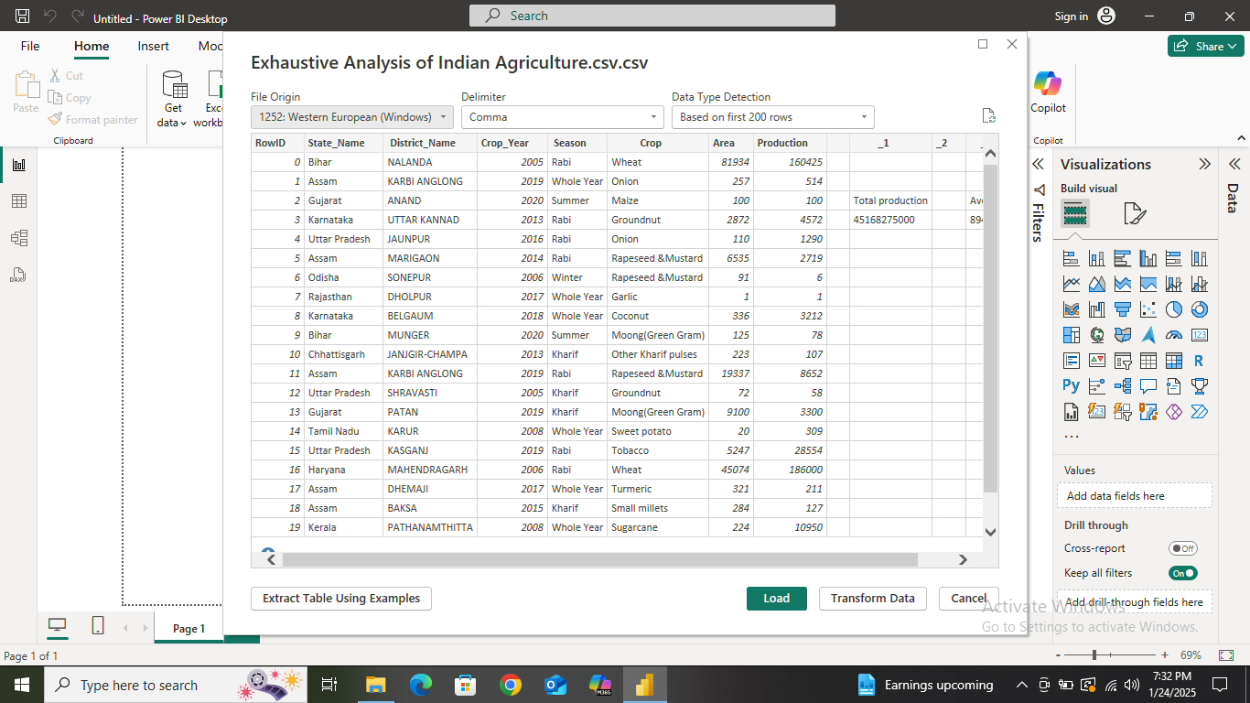

After transform button our data will open in another window (Power Query Editor).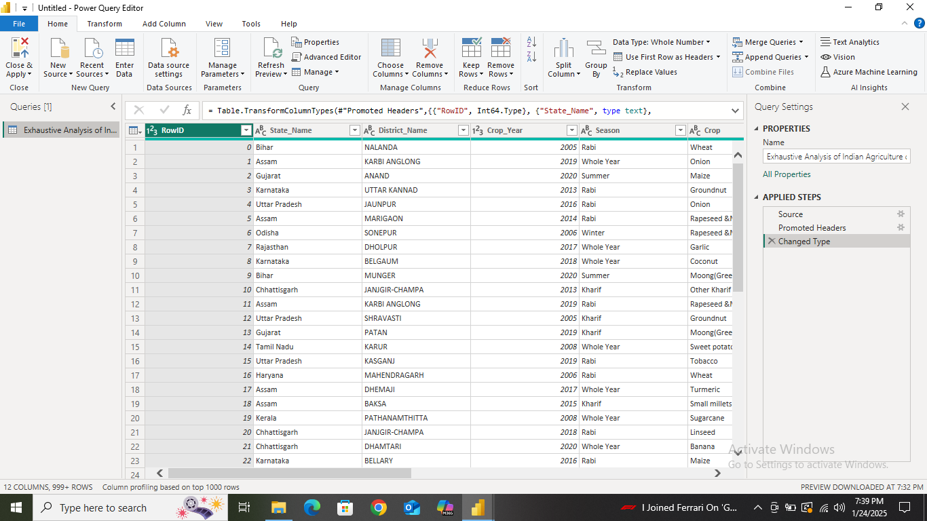

Step 5:Now we have to clean data .

So we will delete the unneccesary columns from data.

To do that we will simple go on column and right click ,we will appear with various operations we can do on column ,Click on Remove and our column will be removed .

We get an update showing that on left of our power bi window.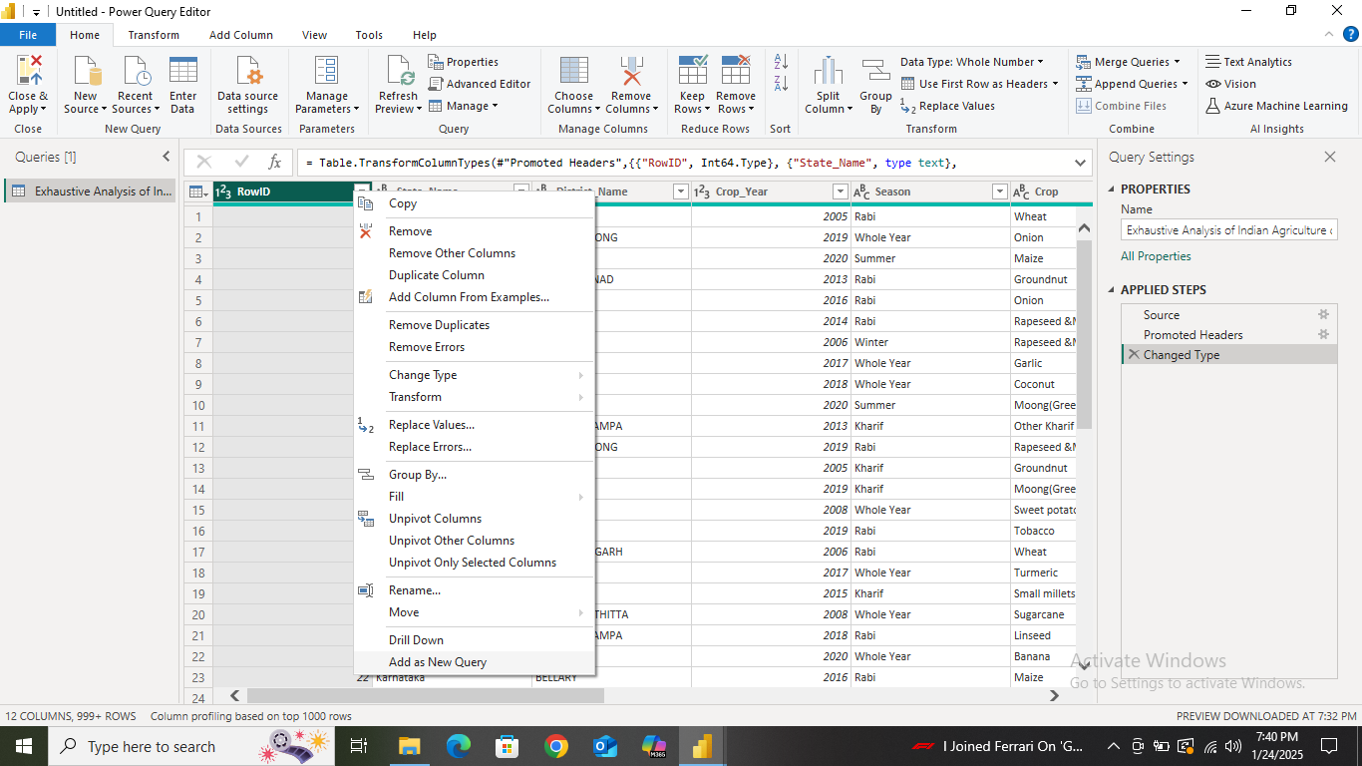

If we want our column back , we just have to click on one button which will appear in applied steps and we will get our column back.

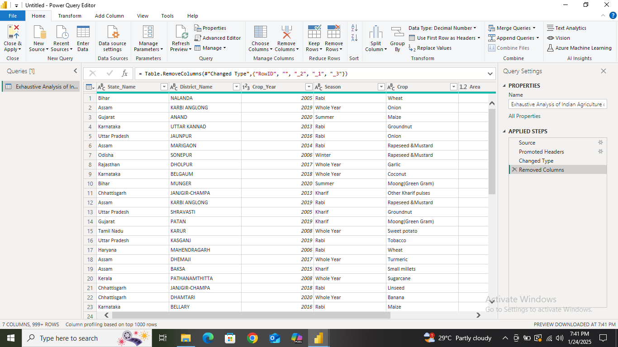

Step 6: Now to check the column quality (null values or unnessesary data) click on View and tick the column quality box .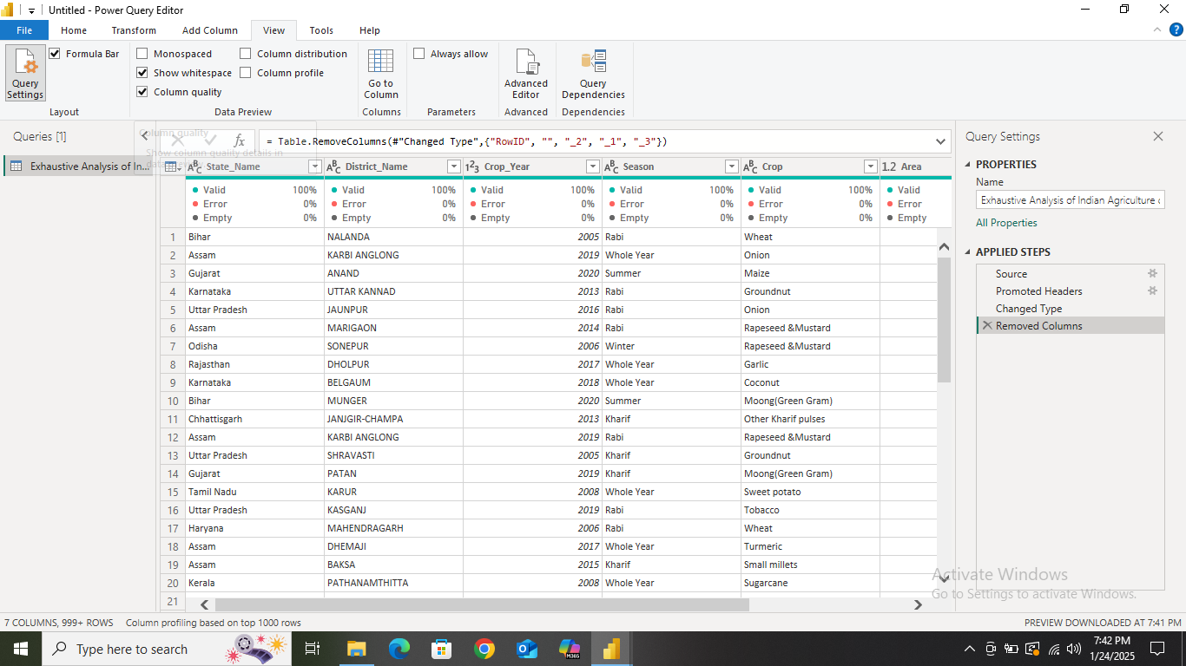

Step 7: go to home , select close and apply then the data will be loaded in Power BI Desktop.